Supplementary Diabetes Management Plan; using The DEXCOM G6

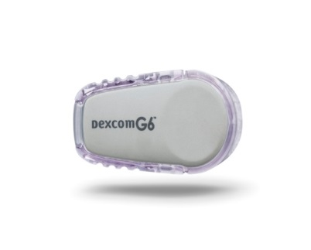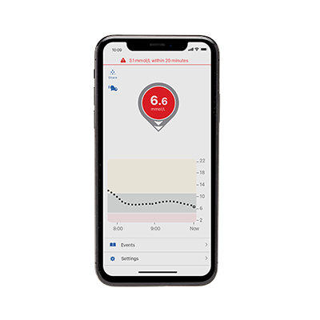

Student Name

School
………………………………………
Review Date: ………………………

This student ………………………………… has Type 1 diabetes, meaning they can no longer produce insulin because the cells in the pancreas that produce it have been destroyed. Without insulin, the body cannot use glucose.

Diabetes cannot be cured, but it can be treated effectively. The aim of the treatment is to keep the blood glucose level close to the normal range (4–7mmol/L, rising to no higher than 10mmol/L two hours after a meal) so it is neither too high (hyperglycaemia) nor too low (hypoglycaemia, also known as a ‘hypo’).

………………………………………….. wears a DEXCOM G6 (Continuous Glucose Monitor). This measures the level of glucose every 5 minutes in the insititial fluid (just underneath the skin).

*Insert DEXCOM G6 Mobile system overview information*.

Blood glucose is checked by checking the screen of the receiver / smart device. Finger prick testing is not required. The Dexcom G6 readings and blood glucose meter readings may not be the same. This is ok as they are reading glucose levels from two different types of bodily fluids; interstitial and blood. Readings may be different but they are still considered accurate.

Target range for blood glucose is 4 – 10 mmol/L

………………….. has low and high glucose alerts set up on their device. The display device will either vibrate or beep based on their settings. …………………… has the following alerts set:

Urgent Low alarm

The DEXCOM G6 has a pre set safety alarm for extremely low blood glucose. This alarm helps protect me from severe hypoglycaemia and cannot be adjusted or switched off. The alarm is activated when the sensor reading is 3.1 mmol / L or lower.

Low Glucose Alert

This alert can help me prevent hypoglycaemia and its unwanted symptoms. This will help me get on with my day without worrying about going low. The low glucose alert level is set at a higher level than 4 to ensure i receives an alert in good time. My Low glucose alert is set at ………………………mmol/L

High Glucose Alert

This enables action to be taken earlier to maintain a stable in range blood glucose reading.
High glucose alert set at: …………………mmol/L

Checking blood glucose levels

There is no need to do usual finger prick tests to check blood glucose levels. Instead of finger pricks you will just need to look at the screen of the receiver / smart device at regular intervals throughout the day to see the G6 Reading (1) (blood glucose level)

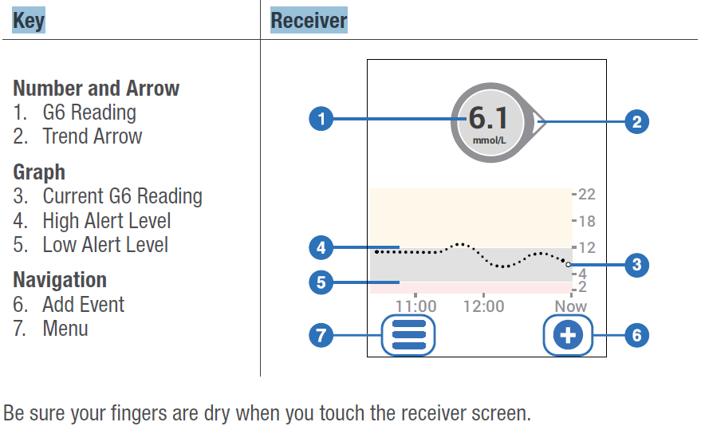

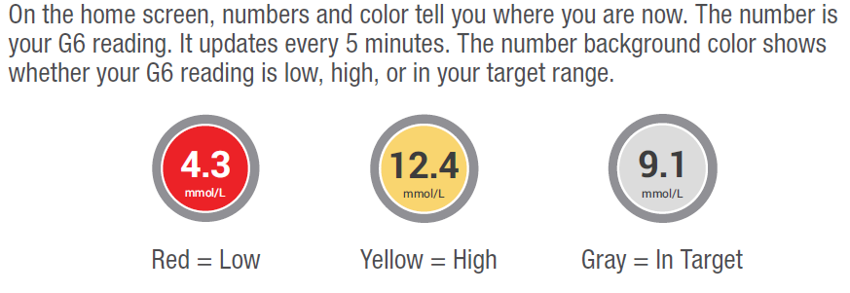

The arrows showing on the screen show the most useful information. The arrows help you make decisions about treatment

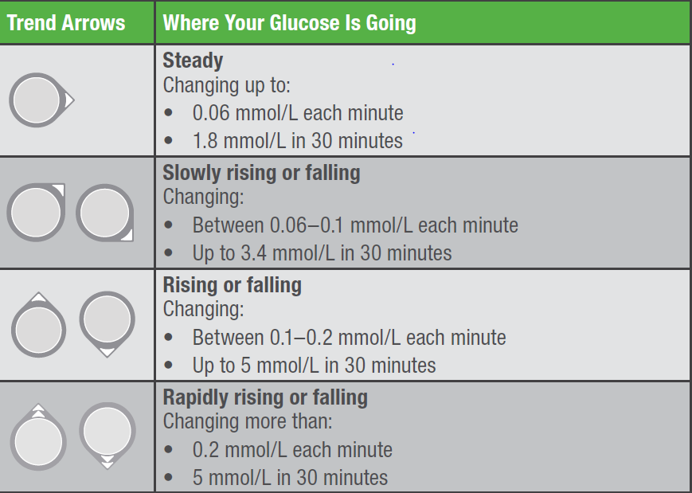

For example, If the child is about to do P.E and the screen shows 5.5 with a downward arrow a snack will be required. However if the arrow is showing an upward trend a snack may not be needed.

Management Plan for the care of Type 1 Diabetes for children on Medtronic 640G insulin pump and using the Dexcom G6.

Childs Name: …………………………………………………………………………………..
Daily Routine

9am Arrive at school …………………………….. will have checked their blood glucose level, administered insulin via the pump and eaten breakfast before leaving for school. This will all be done around ………am and recorded in the home / school communication book.

Break Time Check sensor blood glucose level

……………………………will require insulin for any snack she/he is going to eat.

If sensor blood glucose 10 or above with , then a correction of insulin should be added to any insulin required for a snack.

Lunch Time

The sensor glucose level can be used pre meal with most pumps/meters. Finger prick blood glucose will be required if meter not comapatable to input glucose reading

The sensor / blood glucose reading should be recorded in ……………………………..home / school communication book.

The carbohydrate of the lunch should also be entered into the pump and insulin dose delivered as pump advises.

The child should then eat their lunch ensuring in particular they eat the‘carbohydrate’ part of their lunch.

End of the School Day

Check sensor glucose level. The glucose should be recorded in ………………………………home / school communication book.

Sensor Glucose level below 4
Treat as hypo

Sport & Exercise

Before P.E.

Check sensor glucose level before P.E. Use table below to identify which action to take.

Sensor Glucose 14 or above with or or  Ketones above 0.6mmol  Feels unwell | Sensor Glucose 14 or above with or or  Ketones less than 0.6mmol/l  Feels well | Sensor Glucose 7 or less with or or | Sensor Glucose 7.1 or more with or or
No exercise  Drink plenty of water  Ring Parent  Corrective dose of insulin as per sick day rules / parental advice | Drink plenty of fluids  Able to exercise  10g of fast acting sugar after 30 mins of exercise | 10g carbohydrate prior to exercise  Further 10g of fast acting sugar for every 30 minutes of exercise | Fast acting sugar after every 30 minutes of exercise

Sensor glucose can be checked intermittently throughout any periods of activity.

The body can continue to burn sugar for some time after exercise. The Dexcom G6 sensor allows you to keep a close eye on glucose levels post activity and will alert you if the child’s sensor glucose drops rapidly so you can be proactive and give food to keep levels stable. Insulin will not be required for the snack post activity.

*management of exercise is individual to each child and therefore a clear plan should be discussed with parents and documented *

Blood Glucose Testing

Sensor glucose should be checked pre meal only or anytime when staff are concerned that the child’s glucose levels are low or if they are reporting that they feel low or unwell as this could indicate a very low glucose (below 4) or a high glucose (14 and above).

Treatment of hypoglycaemia (Low Glucose level)

HYPO – Below 4

Symptoms may include:
- Pale
- Lethargic
- Nausea
- Hungry
- Tummy Ache
- Tearful
- Behavioural Change

Check sensor glucose level. If glucose is 3.9 or under treat with fast acting sugar

- Childs preferred hypo treatment

Wait 15 minutes and check sensor glucose level. The following table can be used to determine action

Sensor Reading | Direction arrow | Action
Below 4 |  | If sensor glucose 3.9 or less repeat hypo treatment and wait 15 minutes before rechecking sensor
Above 4 |  | Repeat hypo treatment
Below 4 |  | Wait a further 5 minutes and then check sensor glucose
Above 4 |  | Give slow release carbohydrate (10g Carbohydrate) e.g x2 plain biscuits  OR Meal and insulin

(See flow chart on page )

Hyperglycaemia (High Sensor Glucose)

Hyper – blood glucose 14 or above

Symptoms:

Symptoms may include:
- Headache
- Feeling sick
- Sweating
- Pale
- Irritable / mood change
- Tummy pain
- Feeling thirsty
- Blurred vision
- Behavioural change

Check sensor glucose level. If it is 14 or above with straight or upward arrows, blood glucose should be checked to confirm levels. If blood glucose above 14 then they should also check their ketone levels. A ketone level above 0.6 indicates a lack of insulin and therefore the the child will require an extra dose of insulin. Contact parents for correction dose advice. The child should also be encouraged to drink plenty of water and recheck their blood glucose in 2 hours to see if has come down. During this time their parent should also be contacted to fore warn them and obtain advice as to whether a correction dose of insulin should be given. (See flow chart on page )

SAFETY – Use a blood glucose meter any time the students symptoms don’t match sensor readings. Do not ignore symptoms of high and low glucose. For example a student feels low but the Dexcom G6 mobile shows them to be in normal range.

Parental CONSENT (Delete as appropriate)

Carrying equipment including insulin

- I consent do not consent for my child to carry their medication and equipment upon themselves (delete as appropriate)

- He / She needs to store their insulin and equipment in a safe accessible place. i.e School office

Checking Blood Glucose
- I consent / do not consent for my child to check their Sensor / blood glucose independently

- I consent / do not consent for my child to check their Sensor / blood glucose with minimal supervision. School will document on ‘Blood glucose test and / or Insulin record sheet’

- I consent / do not consent for a member of school staff that has up to date diabetes training to check my child’s sensor / test my child’s blood glucose level. School will document on ‘Blood glucose test and / or Insulin record sheet’.
Administration of Insulin
- I consent / do not consent for my child to self-administer their medication independently

- I consent / do not consent for my child to administer their medication with minimal supervision. School will document on ‘Blood glucose test and / or Insulin record sheet’

- I consent / do not consent for a member of school staff that has up to date diabetes training to administer my child’s insulin via insulin pen. School will document on ‘Blood glucose test and / or insulin record sheet

Responsibility of Parents:

- I understand that the school cannot undertake to monitor the use of self-administered medication carried by the child and that the school is not responsible for any loss of/or damage to any medication or equipment.
- I understand that staff will be acting in the best interests of ……………………………….whilst administering medicines to children
- I will ensure that ……………………………….has hypo treatments at school and extra supplies (see kit list)

- I will ensure that they have their ‘blood glucose meter and ketone meter available at school at all times, including strips & lancets.

- I will ensure that snacks are provided.

- I will ensure that …………………………………………..is fit for school.

- I will be contactable by mobile/landline at all times.

Signed: ………………………………………… (Parent)

PRINT: …………………………………………. Date: …..............

Responsibility of School

- To ensure that the designated members of staff have attended diabetes training and update this training annually (once per academic year)

- To ensure this care plan is updated a minimum of once a year (once per academic year) or at any time there is a change in regimen

- To follow this plan at all times

- To contact parents / diabetes team should they need to query anything or for additional support. Telephone: (0116) 258 6796

- Communicate daily with parents via communication book: blood glucose, insulin doses, stock replenishment etc.

- To ensure that there are appropriately trained staff to support ………………. ………… when he / she moves from one year to the next or during day trips and residential trips

- To ensure there is a plan in place during a fire alarm to ensure that ……………………….. … has the necessary equipment to continue care once evacuated.

- To ensure that plans are in place when sitting exams

Signed: ………………………………………………………School

Print: ………………………………………………………….

Date: ………………………………………………………….

Review Date: ……………………………………………………………………………….

